EPTS OpenMRS

Reports Requirements
Indicator Specification Document
TX_PVLS

Version 2.10

Version

Date | Version | Description | Author
September 3, 2018 | 1.0 | Initial creation of document | Maria Rein
October 8, 2018 | 2.0 | Document structure and content updated | Pinki Meggi
October 24, 2018 | 2.1 | Updated according to MER Indicator reference guide version 2.3 | Kétmia Matavele
November 2, 2018 | 2.2 | Content updated based on recommendations discussed and agreed by PEPFAR C&T team, M&E team, FGH and Jembi. The meeting minutes from 30th October, 2018 attached in Annex 2. | Pinki Meggi
November 5, 2018 | 2.3 | Content updated: business process and technical requirements added. | Pinki Meggi
November 8, 2018 | 2.4 | Content updated: additional FGH and Jembi Logos added, comments deleted, chapter III renamed from “Business Process” to “Report Process Analysis”, legend added for report process diagrams, bookmarks added for requirements, pseudo code added in technical requirements and approval section added after versioning section. | Pinki Meggi
November 8, 2018 | 2.5 | Overall revision | Zainabe Dadá
December 4, 2018 | 2.6 | Overall revision on key assumptions and depth technical review | FGH team
December 13, 2018 | 2.7 | FGH changes and overall revision: business process, key assumptions, requirements, pseudocode, annexes. | Pinki Meggi
April 10, 2019 | 2.8 | Modifications made to clarify how the current code works.  - with >6 months on ART with one VL result registered in the 12-month period between 6-9 months after ART initiation.  - the VL result registered in the 12-month period that is not the first one registered for the patient, and the previous VL was registered between 12-15 months with a result of <1000 copies  - the code will look at pregnant and breastfeeding regardless of the sex of the patient  Simple scenarios included to clarify the requirements | Maria Rein
May 7, 2019 | 2.9 | Changes in the document format:  - Chapter II Business Process removed;  - Chapter VI Testing Scenario removed;  - PVLS Reporting Period Dates updated in pag.8;  Changes in the requirements:  - Pregnant and Breastfeeding requirements changed to not check for female patients;  - Pregnant requirement changed to search in previous 9 months instead of 12 months  - Breastfeeding requirement changed to search in previous 18 months instead of 12 months  - Modifications in Routine Disagreggation Criterias updated based on discussion occurred during PVLS Review Meeting on 6th May 2019 between CDC Team (Seth, Ferreira, Maria) FGH Team (Tique, Eurico) and Jembi Team (Pinki, Zainabe). | Pinki Meggi
May 24, 2019 | 2.10 | Changes in the document content:  - Corrected the assumption in chapter 2  - Re-organized the assumptions along the document | Pinki Meggi

Approvals and Sign-off

Document Title: EPTS OpenMRS Indicator Specification and Requirements – TX_PVLS
Year: 2019

Approvals
Approval of the requirements is finalized by the project officer for JEMBI who is responsible for obtaining approval from the programmatic staff responsible for defining the requirements. This can include the PEPFAR CDC and USAID M&E Team along with PEPFAR programmatic staff and PEPFAR clinical / implementing partners.

Authors
The Authors signatures represent the EPTS Requirements Gathering Group composed by two CDC Partners, Jembi Health Systems (HIS Partner) and FGH (Clinical Partner) and signify that this document is complete and that, to the best of their knowledge, it adequately addresses the document’s intended purpose and scope and it is accurate.

Table of Contents

Version 2
Approvals and Sign-off 4
Table of Contents 5
I Introduction 6
I.a Purpose 6
I.b Scope 6
I.c Reports 6
I.d References 6
II. Indicator Definition 6
II.a Description 6
II.b Numerator and Denominator 7
II.c Indicator Reporting Level and Frequency 7
II.d Indicator Primary Sources 7
II.e Population 8
II.f Disaggregation 8
II.g Report Output 10
III. Requirements definition 11
III.a Key Assumptions 11
IV.b List of Functional Requirements 11
IV. ANNEXES 17
1. Attendance 0
2. Agenda 0
7. Post Meeting Action Items 2
8. Next Meeting 2

I Introduction

I.a Purpose
The purpose of this document is to capture the requirements and specifications for the PEPFAR MER TX_PVLS Indicator. This indicator is reported from the EPTS OpenMRS system in use by the PEPFAR Clinical partners to capture patient level data in retrospective mode at the health facilities.

I.b Scope
This document explains the indicator definition, describes the indicator reporting process, and defines the functional and technical requirements to generate the indicator in an OpenMRS Report. The link to testing scenarios document is also included.

The indicator definition is based on PEPFAR MER (Monitoring, Evaluation, and Reporting) Indicator Reference Guide specified below in I.c References.

I.c Reports
TX_PVLS is included in the following reports:
PEPFAR MER 2.3 SEMI ANNUAL
Please refer to the PEPFAR MER 2.3 SEMI ANNUAL Report Requirements for specifications for this report.

I.d References
MER 2.3 Indicator Reference Guide
Ficha de Seguimento Adult and Pediatric
Processo Clínico
Any other forms (i.e., FSR, Laboratório)

II. Indicator Definition

II.a Description
TX_PVLS, viral suppression type of indicator, reports the percentage of ART patients with a suppressed viral load (VL) result (<1000 copies/ml) documented in the medical or laboratory records/laboratory information systems (LIS) within the past 12 months.

This indicator monitors the proportion of documented viral load results from adult and pediatric ART patients who have been on ART for at least 3 months with a suppressed result (<1,000 copies/ml). This indicator will provide data on patients who have a viral load (VL) test in the past 12 months and the percentage who were virally suppressed at the most recent test.

II.b Numerator and Denominator
TX_PVLS numerator is the number of ART patients with suppressed VL results (<1000 copies/ml) documented in the medical or laboratory records/LIS within the past 12 months.

TX_PVLS denominator is the number of ART patients with a VL result documented in the medical or laboratory records/LIS within the past 12 months.

Key Assumptions:
- If there is more than one VL result for a patient during the past 12 months, report the most recent result.
- Only patients who have been on ART for at least 3 months (this will be determined comparing date of ART initiation and the date when the last VL was registered) should be considered.
- Only VL tests with recorded results and VL results that are linked back to patients should be included in the numerator and denominator of this indicator.
- If a PEPFAR-supported treatment site (i.e. a site that has reported TX_PVLS) has not collected any samples for VL testing, “0” should be entered for both the numerator and denominator.

II.c Indicator Reporting Level and Frequency
TX_PVLS is a facility-level indicator, collected at health facilities.

TX_PVLS is reported at each PEFPAR quarterly reporting cycle.

The PEPFAR partners are required to report quarterly for the following reporting periods:
Q1 September 21st – December 20th
Q2 December 21st – March 20th
Q3 March 21st – June 20th
Q4 June 21st – September 20th

TX_PVLS Indicator is reported in all four reporting cycles, Q1, Q2, Q3 and Q4 for correspondent last 12 month periods results each quarter, as described in the following image for FY19:

Figure 1. TX_PVLS 12 month period reported each quarter for FY19 (Source: Q3 Partner Meeting Presentation v201809131254).

Thus in case of TX_PVLS Indicator the reporting period will be the following:
Q1 January 21st – December 20th
Q2 April 21st – March 20th
Q3 July 21st – June 20th
Q4 October 1st – September 20th

II.d Indicator Primary Sources
The TX_PVLS indicator viral load data in EPTS is captured from the following forms (i.e., tools) in EPTS

- Ficha de Seguimento
- Processo Clínico
- Ficha de Laboratório (Laboratory Form)

II.e Population
TX_PVLS population includes:
- Patients on ART (Adults including pregnant and breastfeeding woman, Children) for at least 3 months who initiated or transferred-in during the reporting period with a VL result documented in the medical or laboratory records/LIS within the past 12 months.

II.f Disaggregation
The TX_PVLS numerator and denominator should be reported disaggregated by two groups:
- Indication by sex/age: disaggregate first by type of VL test as Routine, Targeted or Not Documented, then by Sex, as Female or Male, and then by Age, as <1, 1-4, 5-9, 10-14, 15-19, 20-24, 25-29, 30-34, 35-39, 40-44, 45-49, 50+ and Unknown Age.
- Indication by pregnant/breastfeeding: disaggregate first by pregnant/breastfeeding and then by type of VL test as Routine, Targeted or Not Documented.

Age represents an individual’s age at the end of the reporting period or when last seen at the facility. For example, a 14-year-old child will be counted as currently receiving treatment in the <15 age category at the end of reporting period “A”. During reporting period “B” the child turns age 15 and so at the end of this reporting period the child will be counted under the 15+ age category.
Routine refers to VL tests obtained at standard intervals following ART initiation to monitor virologic response to ART and includes follow-up VL tests done after an initial VL result of VL>=1000.
Target refers to viral load tests ordered based on specific clinical indication eg. concern about disease progression or failure to respond to ART.
Not documented means not indicated in the patient file, registry or log book whether this test was target or routine.

The recommendations from PEPFAR C&T and M&E teams, FGH clinical team and Jembi technical team, based on attached meeting notes (Annex 2), are the following:

ROUTINE
To disaggregate de DENOMINATOR as ROUTINE viral load tests for which the results were registered in the 12-month period, the following was proposed:

Adults and Children
- adults and children with more than 6 months on ART with the most recent VL result registered in the 12-month period between 6-9 months after ART initiation and no VL result within the first 6 months. Summarized as:
  - (most recent vl date – art initiation date) > 6 and <=9 months
and
  - no VL registered between ART initiation date and (ART initiation date+6 months)
- adults and children with the most recent VL result registered in the 12-month period that is not the first one registered for the patient, and there is a VL with a result of “<1000 copies” registered between 12 and 15 months before the most recent VL result. Summarized as:
  - vl_result <1000 copies
And
  - (vl_date – most_recent_vl_date) >= 12 months and (vl_date – most_recent_vl_date) <= 15 months
- adults and children with the most recent VL result registered in the 12-month period registered between 6 and 9 months after changing from first to second line treatment for patients on second line treatment and without any VL result registered during the first 6 months after changing from first to second line. Summarized as:
  - Patient on 2nd line treatment
And
  - (most recent vl date – therapy_changing_date) >=6 and <=9 months
And
  - no other VL registered between (therapy_changing_date) and (therapy changing date + 6months)
Pregnant and Lactating women (PLW)
- pregnant and breastfeeding patients with more than 3 months on ART with the most recent VL result registered in the 12-month period between 3-6 months after ART initiation and no VL result within the first 3 months. Summarized as:
  - (most recent vl date – art initiation date) <=6 months (since the included patients are on ART for more than 3 months)
and
  - no VL registered between ART initiation date and (ART initiation date+3 months)
- pregnant and breastfeeding patients with the most recent VL result registered in the 12-month period that is not the first one registered for the patient, and there is a VL with a result of “<1000 copies” registered before the most recent VL result. Summarized as:
  - vl_result <1000 copies
And
  - (vl_date < most_recent_vl_date)
- pregnant and breastfeeding patients with the most recent VL result registered in the 12-month period registered between 6 and 9 months after changing from first to second line treatment for patients on second line treatment and without any VL result registered during the first 6 months after changing from first to second line. Summarized as:
  - Patient on 2nd line treatment
And
  - (most recent vl date – therapy_changing_date) >=6 and <=9 months
And
no other VL registered between (therapy_changing_date) and (therapy changing date + 6months)

TARGETED
It’s not possible to disaggregate the DENOMINATOR as TARGETED VL due to limitations on the currently used tools.

UNDOCUMENTED
All other VL results not classified/Disaggregated as ROUTINE that were registered in the 12-months period.

CODE MODIFICATIONS:
- Patients marked as pregnant or breastfeeding regardless of their sex will be included in the pregnant and breastfeeding disaggregation.

II.g Report Output
The report output for TX_PVLS indicator can be found here.

III. Requirements definition

III.a Key Assumptions
The key assumptions for TX_PVLS indicator and related to EPTS OpenMRS are the following:
- All patients captured in the OpenMRS system are HIV positive.
- All patients captured in the OpenMRS system have been on antiretroviral therapy (ART) at one time.
- All transferred-in patients are HIV positive and are on ART.
- The primary source for TX_PVLS indicator is the Laboratory (formulario de solicitacao de Carga viral) as Annex 1 and Ficha de Seguimento.
- The primary source for TX_PVLS Indicator does not include FSR.
- The target results are not possible to calculate, and will be reported as “0” or empty. Hence the target disaggregation is not be included in the TX_PVLS denominator and numerator report template.
- Only patients who have been on ART for at least 3 months (this will be determined comparing date of ART initiation and the date when the last VL was registered) will be considered.
- Patients marked as pregnant or breastfeeding regardless of their sex will be included in the pregnant and breastfeeding disaggregation until the data quality repor tis included in the reports module.
- Patients marked as pregnant or breastfeeding regardless of their age will be included in the pregnant and breastfeeding disaggregation.
- Patients that are children < 15 years and pregnant or breastfeeding will fall into the pregnancy or breastfeeding category.
- The PEPFAR MER Reports in OpenMRS are named “PEPFAR MER Quarterly Report for quarterly reporting (Q1, Q2, Q3, Q4)

IV.b List of Functional Requirements
Requirement # | Category/  Functional Area | Requirement
PVLS_FR1 | Reports | The system will generate the TX_PVLS indicator report (denominator - PVLS_FR2 and numerator- PVLS_FR3 ) under “PEPFAR MER Quarterly Report” for selected reporting period (start and end dates) and specific location (health facility).
PVLS_FR2 | Indicator denominator | The system will generate the TX_PVLS indicator denominator as number of patients on ART for at least 3 months with VL result documented in the last 12 months from reporting end date ( PVLS_FR6 ) with the specified disaggregation ( PVLS_FR4 ).  The patients included are the following:  - Patients with at least one (the most recent one) VL documented in the Laboratory or Ficha de Seguimento Forms in the last 12 months from the reporting end date.  Excluding:  - Patients on ART for less than 3 months since the most recent VL date.
PVLS_FR3 | Indicator numerator | The system will generate the TX_PVLS indicator numerator as number of patients on ART for at least 3 months with suppressed VL result documented in the last 12 months from reporting end date ( PVLS_FR7 ) , with the specified disaggregation (PVLS_FR5).  The patients included are the following:  - Patients with at least one (the most recent one) VL documented in the Laboratory or Ficha de Seguimento Forms in the last 12 months from the reporting end date, with result < 1000 copies/ml documented.  Excluding:  - Patients on ART for less than 3 months since the most recent VL date.
PVLS_FR4 | Indicator Disaggregation- denominator | The system will generate the TX_PVLS indicator denominator with following disaggregation:  - Pregnant (PVLS_FR8) or Breastfeeding (PVLS_FR9)  - VL Result Routine (PVLS_FR11) or not Documented (PVLS_FR12).  - Children  - VL Result Routine (PVLS_FR10) or not Documented (PVLS_FR12)  - Sex: Male/Female  - Age: <1, 1-4, 5-9 (PVLS_FR14)  - Adults (including Pregnant or Breastfeeding adults)  - VL Result Routine (PVLS_FR10) or not Documented (PVLS_FR12)  - Sex: Male/Female  - Age: 10-14, 15-19, 20-24,25-29,30-34,35-39,40-44,45-49, >=50,Unknown age (PVLS_FR14)
PVLS_FR5 | Indicator Disaggregation- numerator | The system will generate the TX_PVLS indicator numerator with following disaggregation:  - Patient Pregnant (PVLS_FR8) or Breastfeeding (PVLS_FR9)  - VL Result Routine (PVLS_FR11) or not Documented (PVLS_FR13).  - Children  - VL Result Routine (PVLS_FR10) or not Documented (PVLS_FR13)  - Sex: Male/Female  - Age: <1, 1-4, 5-9 (PVLS_FR14)  - Adults (including Pregnant or Breastfeeding adults)  - VL Result Routine (PVLS_FR10) or not Documented (PVLS_FR13)  - Sex: Male/Female  - Age: 10-14, 15-19, 20-24,25-29,30-34,35-39,40-44,45-49, >=50,Unknown age (PVLS_FR14)
PVLS_FR6 | Patients with VL result and on ART for at least 3 months | The system will generate the number of patients that are on ART for at least 3 months as following:  - Based on the list of patients who have the most recent VL result registered within 12 months’ prior end of reporting period exclude all patients who have  - the difference between the date of the most recent viral load result in the last 12 months and the ART initiation date lower than 3 months
PVLS_FR7 | Patients with suppressed VL Result and on ART for at least 3 months | The system will generate the number of patients that are on ART for at least 3 months with VL result<1000 copies/ml as following:  - Based on the list of patients who have the last VL result registered within 12 months’ prior end of reporting period exclude patients who have  - the difference between the date of the last viral load in the last 12 months and the patient date of initiation of ART lower than 3 months and  - the most recent VL result is less than 1000
PVLS_FR8 | Patients disaggregation - pregnant | The system will identify patients who are pregnant as following:  - Patients marked as “PREGNANT” in the initial consultation or follow-up consultation during the period range or  - Patients who have “Number of weeks Pregnant” registered in the initial or follow-up consultation during the period range or  - Patients who have “Pregnancy Due Date” registered in the initial or follow-up consultation during period range or  - Patients enrolled on PTV/ETC program during the period range.  If the patient has the both state (pregnant and breastfeeding) the most recent one should be considered.  - Period range:  - start_date = the most recent VL result date - 9 months  - end_date = the most recent VL result date
PVLS_FR9 | Patients disaggregation - breastfeeding | The system will identify women patients who are breastfeeding as following:  - Patients who have the “Delivery date” registered in the initial or follow-up consultations and where the delivery date is between the period range or  - Patients who started ART for being breastfeeding as specified in “CRITÉRIO PARA INÍCIO DE TRATAMENTO ARV” in the initial or follow-up consultations that occurred between period range or  - Patients who have been registered as breastfeeding in follow up consultation during the period range.  - Patients enrolled on PTV/ETC program with state 27 (gave birth) during the period range.  If the patient has the both state (pregnant and breastfeeding) the most recent one should be considered.  - Period range:  - start_date = the most recent VL result date - 18 months  - end_date = the most recent VL result date
PVLS_FR10 | Patients disaggregation – routine for adults and children | The system will identify patients with routine type of VL test for adults (including pregnant and breastfeeding) and children as following:  - adults and children with more than 6 months on ART with the most recent VL result registered in the 12-month period between 6-9 months after ART initiation and no VL result within the first 6 months. Summarized as:  - (most recent vl date – art initiation date) > 6 and <=9 months  and  - no VL registered between ART initiation date and (ART initiation date+6 months)  - adults and children with the most recent VL result registered in the 12-month period that is not the first one registered for the patient, and there is a VL with a result of “<1000 copies” registered between 12 and 15 months before the most recent VL result. Summarized as:  - vl_result <1000 copies  And  - (vl_date – most_recent_vl_date) >= 12 months and (vl_date – most_recent_vl_date) <= 15 months  - adults and children with the most recent VL result registered in the 12-month period registered between 6 and 9 months after changing from first to second line treatment for patients on second line treatment and without any VL result registered during the first 6 months after changing from first to second line. Summarized as:  - Patient on 2nd line treatment  And  - (most recent vl date – therapy_changing_date) >=6 and <=9 months  And  - no other VL registered between (therapy_changing_date) and (therapy changing date + 6months)
PVLS_FR11 | Patients disaggregation – routine for pregnant and breastfeeding women | The system will identify patients with routine type of VL test as following:  - pregnant and breastfeeding patients with more than 3 months on ART with the most recent VL result registered in the 12-month period between 3-6 months after ART initiation and no VL result within the first 3 months. Summarized as:  - (most recent vl date – art initiation date) <=6 months (since the included patients are on ART for more than 3 months)  and  - no VL registered between ART initiation date and (ART initiation date+3 months)  - pregnant and breastfeeding patients with the most recent VL result registered in the 12-month period that is not the first one registered for the patient, and there is a VL with a result of “<1000 copies” registered before the most recent VL result. Summarized as:  - vl_result <1000 copies  And  - (vl_date < most_recent_vl_date)  - pregnant and breastfeeding patients with the most recent VL result registered in the 12-month period registered between 6 and 9 months after changing from first to second line treatment for patients on second line treatment and without any VL result registered during the first 6 months after changing from first to second line. Summarized as:  - Patient on 2nd line treatment  And  - (most recent vl date – therapy_changing_date) >=6 and <=9 months  And  - no other VL registered between (therapy_changing_date) and (therapy changing date + 6months)
PVLS_FR12 | Patients disaggregation - not documented for denominator | The system will identify patients with not documented type of VL test in denominator disaggregated as following:  - Breastfeeding disaggregation: breastfeeding patients identified for denominator excluding the breastfeeding patients identified for denominator with routine VL tests.  - Pregnant disaggregation: pregnant patients identified for denominator excluding the pregnant patients identified for denominator with routine VL tests.  - Children disaggregation: children patients identified for denominator excluding the children patients identified for denominator with routine VL tests.  - Adult disaggregation: adult patients identified for denominator excluding the adults patients identified for denominator with routine VL tests.
PVLS_FR13 | Patients disaggregation - not documented for numerator | The system will identify patients with not documented type of VL test in numerator disaggregated as following:  - Breastfeeding disaggregation: breastfeeding patients identified for numerator excluding the breastfeeding patients identified for numerator with routine VL tests.  - Pregnant disaggregation: pregnant patients identified for numerator excluding the pregnant patients identified for numerator with routine VL tests.  - Children disaggregation: children patients identified for numerator excluding the children patients identified for numerator with routine VL tests.  - Adult disaggregation: adult patients identified for numerator excluding the adults patients identified for numerator with routine VL tests.
PVLS_FR14 | Patients  Disaggregation-  age | The system will identify patients age for disaggregation intervals as following:  - Patients with birth date information registered in the system should be calculated the age of the patient at the reporting end date (birth date minus reporting end date)  - Patients without birth date information should be considered as unknown age.
PVLS_FR15 | Reporting Period | The user will enter as input parameters the “reporting start date” and “reporting end date”. The “reporting start date” is defined by the beginning of the correspondent quarter reporting period. The “reporting end date” is defined by the end of the reporting period.  Q1 September 21st – December 20th  Q2 December 21st – March 20th  Q3 March 21st – June 20th  Q4 June 21st – September 20th

IV. ANNEXES
Annex 1- OpenMRS EPTS Laboratory Form
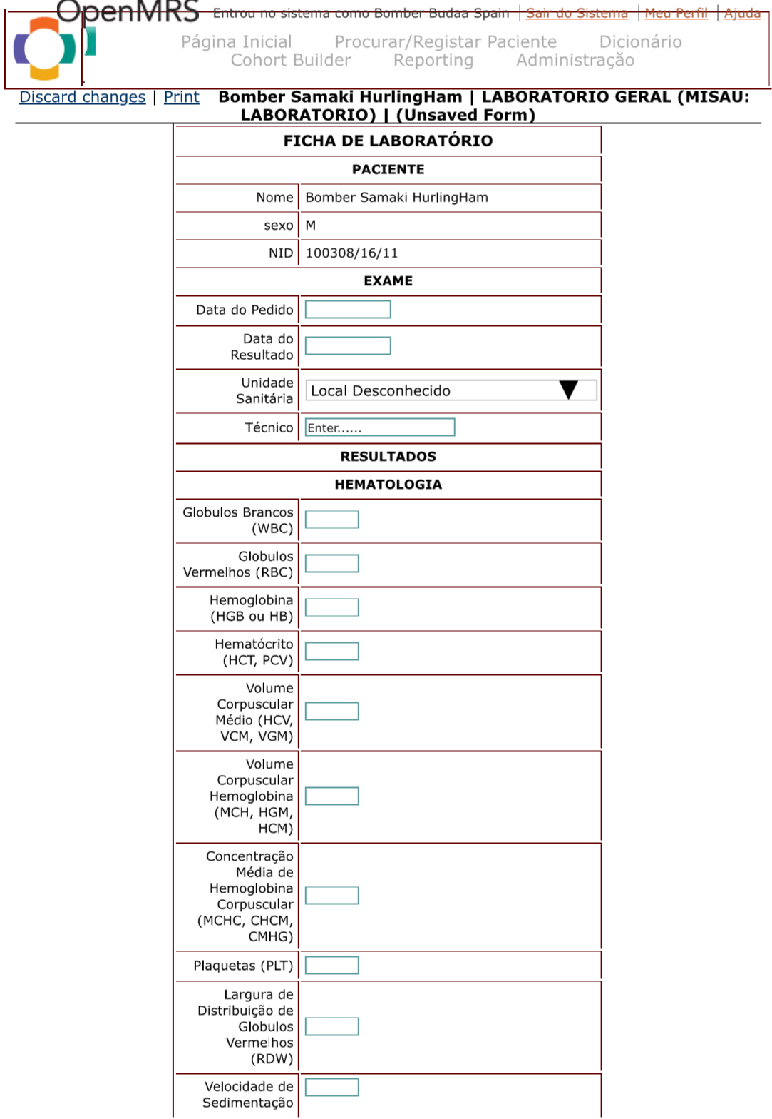

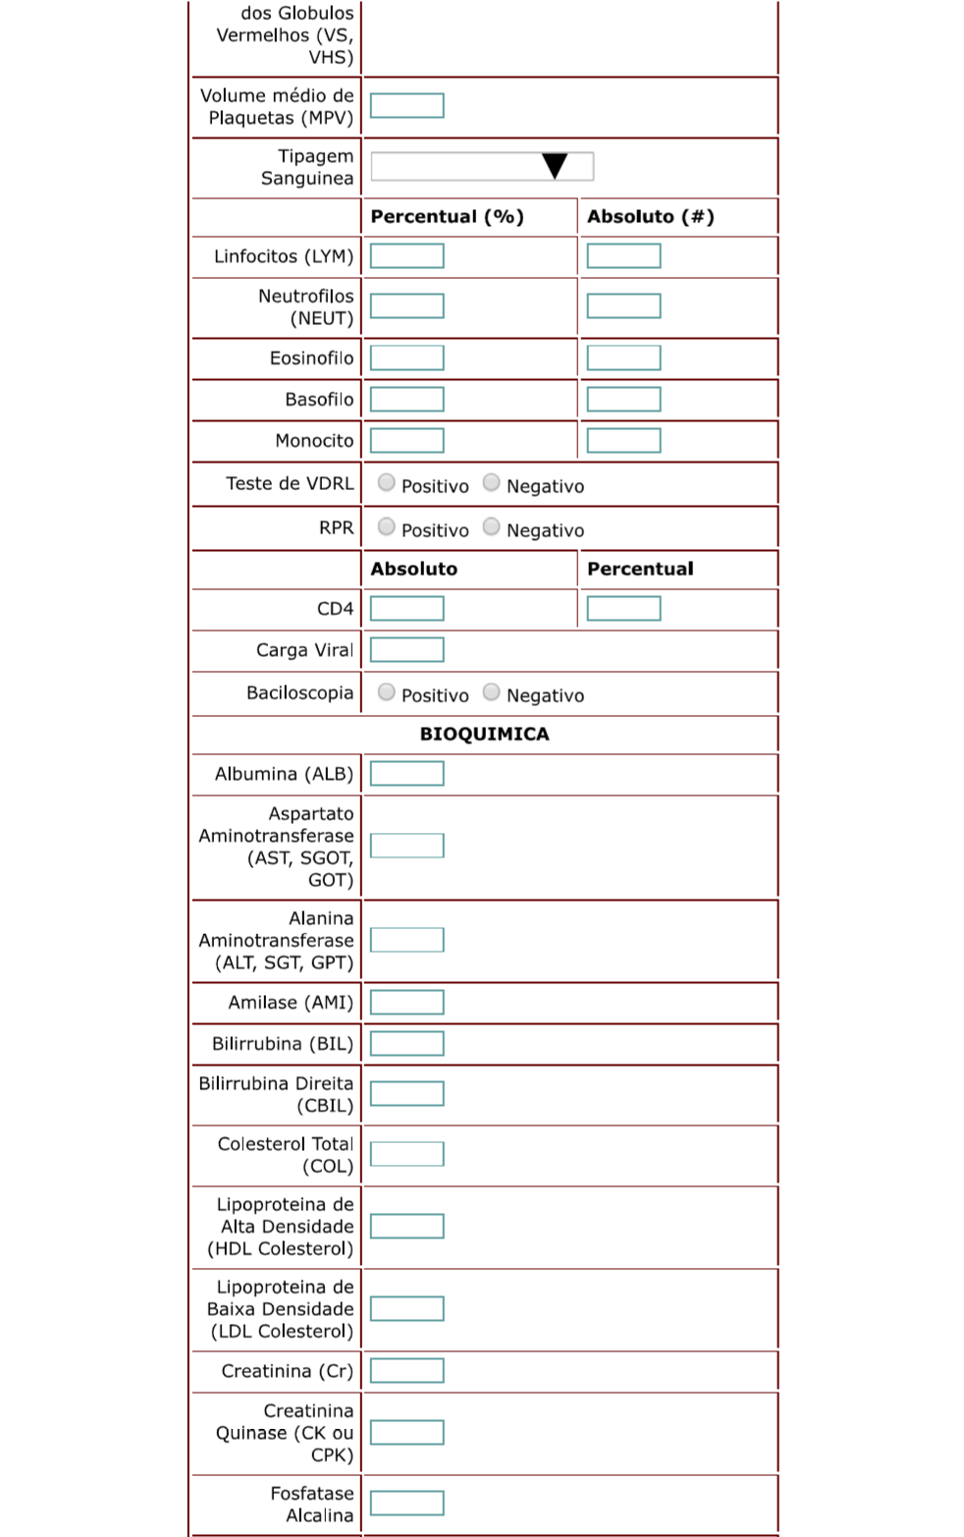
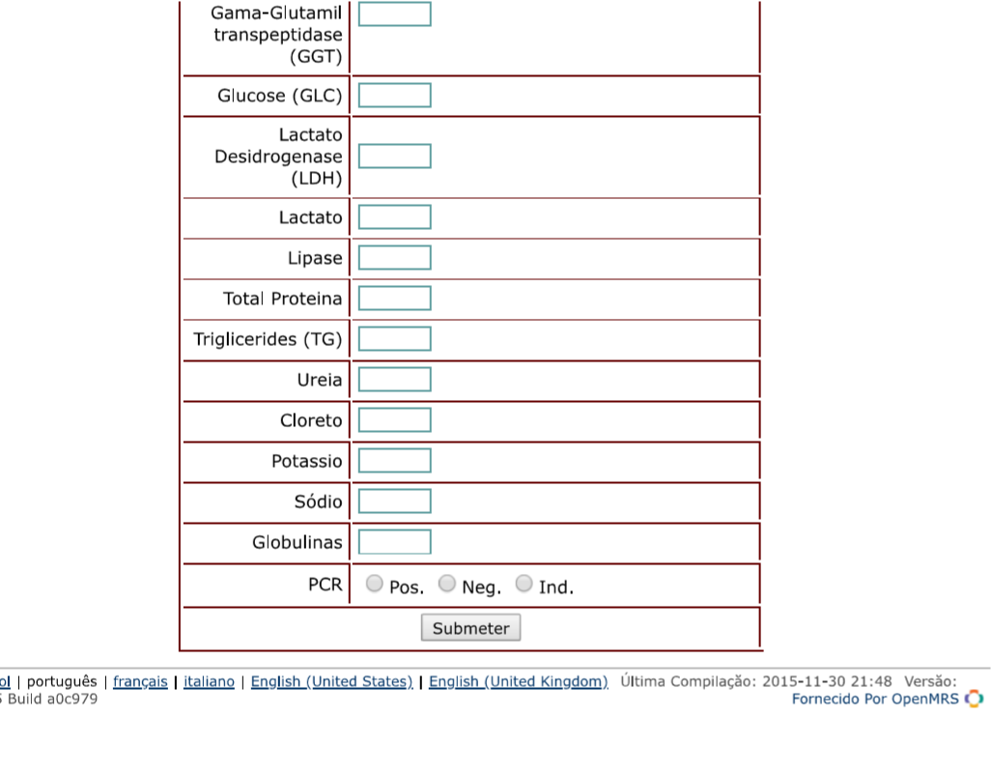

Annex 2- Recommendations for VL Disaggregation - Meeting Notes from 30th October 2018

PEPFAR | FGH | Jembi Moasis Open MRS indicator Clarification Meeting

Meeting Minutes
Meeting Date: 10/30/2018 8.30am – 10.00am
Meeting Location: CDC JAT - CIBUM
Draft

Attendance

Organization | Names
CDC | Agnaldo Guambe, Maria Rein, Madona Raja
FGH | Fernanda Alvim, José Tique, Stelio Moiane
Jembi | Zainabe Dadá, Pinki Meggi, Paulo Matsinhe, Ketmia
PCO/PEPFAR | Joel Chebab, Charity Alfredo, Nidze Guilovica

Agenda
- Charity and Nidze set to discuss the proposal that was send by Tique:
To summarize our alternative proposal:
- We do not recommend changes to the existing query for this MER indicator, which is measuring the overall viral suppression rate based on VL test results over the 12 month periods.
So, we think that the disaggregation should follow the same basic premise.

To disaggregate de DENOMINATOR between TARGETED AND ROUTINE viral load tests for which the results were registered in the 12 month period, we propose the following:
- ROTINE VL=
First Viral Load test result EVER (the patient does not have a previous VL test result registered)
The Viral load result registered in the 12-month period is not the first one registered for the patient and the previous VL result had <1000 copies.
The viral load result registered in the 12 month period is the first viral load registered after changing from first to second line treatment for patients on second line treatment
The viral load test result registered in the 12-month period is not the first viral load registered for the patient and the patient is a pregnant or breastfeeding woman and the previous VL result had less than 1000 copies
- TARGETED VL=
All other VL results which were registered in the 12-month period

Note: as defined in the MER 2.3 guide, in case a patient has two VL results in the same period, only the last VL result is taken into account.

- DISCUSSION ON THE PROPOSED RECOMMENDATIONS

ROUTINE VL
- There were concerns with the first point in the proposed recommendations (First Viral Load test result EVER if the patient does not have a previous VL test result registered). While it tries to accommodate the first viral load ever performed to a patient as a ROUTINE VL, this may not be applicable for all patients, particularly in HF/districts where the test and start strategy has not been implemented yet, where the first viral load may be requested for specific clinical conditions (TARGETED VL). It was then a final recommendation to follow strictly the national guidelines when classifying VL results as ROUTINE. A decision to keep the initial recommendations that follow strictly the guidelines was made, namely:
  - Two different criteria to classify the first requested VL as per national guidelines
    - Adults + Children: patients >6 months on ART with one VL result in 6-9 months after ART initiation.
    - Pregnant and Lactating women: patients >3 months on ART with one VL result in 3-6 months after ART initiation.
- A suggestion to add a time limit to when the previous VL test was performed in the second proposed recommendation was made. It should now read:
  - ” The Viral load result registered in the 12-month period is not the first one registered for the patient and the previous VL was performed between 12-15 months with a result of <1000 copies”
- To follow MER 2.3 guidelines, a decision to add a condition that describes as ROUTINE VL all results registered in the 12-month period that are not the first one registered for the patient and the previous VL had a result of >1000 copies. According to the national guidelines this condition would be applicable for TARGETED VL, but MER 2.3 considers it as ROUTINE.
- All other recommendations on ROUTINE VL were consensus.

TARGETED VL
As per MER 2.3 a TARGETD VL refers to viral load tests ordered based on a specific clinical indication, (e.g., concern about disease progression or failure to respond to ART). Due to current limitations to correctly identify TARGETED VL as per MER 2.3 guidelines, we will consider all other requested VL as Undocumented. It is expected that with the rollout of the new HIV M&A tools this limitation will be solved.

- THE SUMMARIZE PROPOSAL NOW READS:

ROUTINE VL
To disaggregate de DENOMINATOR as ROUTINE viral load tests for which the results were registered in the 12-month period, we propose the following:

- Adults and Children with >6 months on ART with one VL result registered in the 12-month period between 6-9 months after ART initiation.
- Pregnant and Lactating women with >3 months on ART with one VL result registered in the 12-month period between 3-6 months after ART initiation
- Adults and Children with the VL result registered in the 12-month period that is not the first one registered for the patient, and the previous VL was registered between 12-15 months with a result of <1000 copies.
- The viral load result registered in the 12-month period is the first viral load registered after changing from first to second line treatment for patients on second line treatment
- Pregnant and Lactating women in which the viral load test result registered in the 12-month period is not the first viral load registered for the patient, and the previous VL result had <1000 copies

TARGETED
We are not able to disaggregate the DENOMINATOR as TARGETED VL due to limitations on the currently used tools.

UNDOCUMENTED
We will consider as UNDOCUMENTED, all other VL results not classified/Disaggregated as ROUTINE that were registered in the 12-month period.

- NEXT STEPS
  - SI/CLINICAL leads need to update the guidance to all partners
    - Partners meeting around November 15th where PEPFAR will communicate to all about the package of this indicator
  - FGH will right the proposals and scenarios on the context of patients with those characteristics,

- UPDATES ON TX_CURR
- 99/198 days as per AH approvals
- Need to do the same for TX_RET for numerator
- Same with TX_CURR and TX_CURR 99 we would like to have TX_RET and TX_RET 99
  - Teste scenarios need to have patients with next pick up
  - When the test scenarios for the expected results are ready need to be shared with Herminio and Ferreira for feedback, so it need to be ready by the first week of December.

Post Meeting Action Items
# | Action | Assigned To | Deadline
1 | SI leads needs to update the guidance for all partners | SI team
2 | FGH will right the proposals and scenarios | FGH

Next Meeting
Next Meeting: Monday 5th November ,2018
Annex 3- Adult Consultation Form
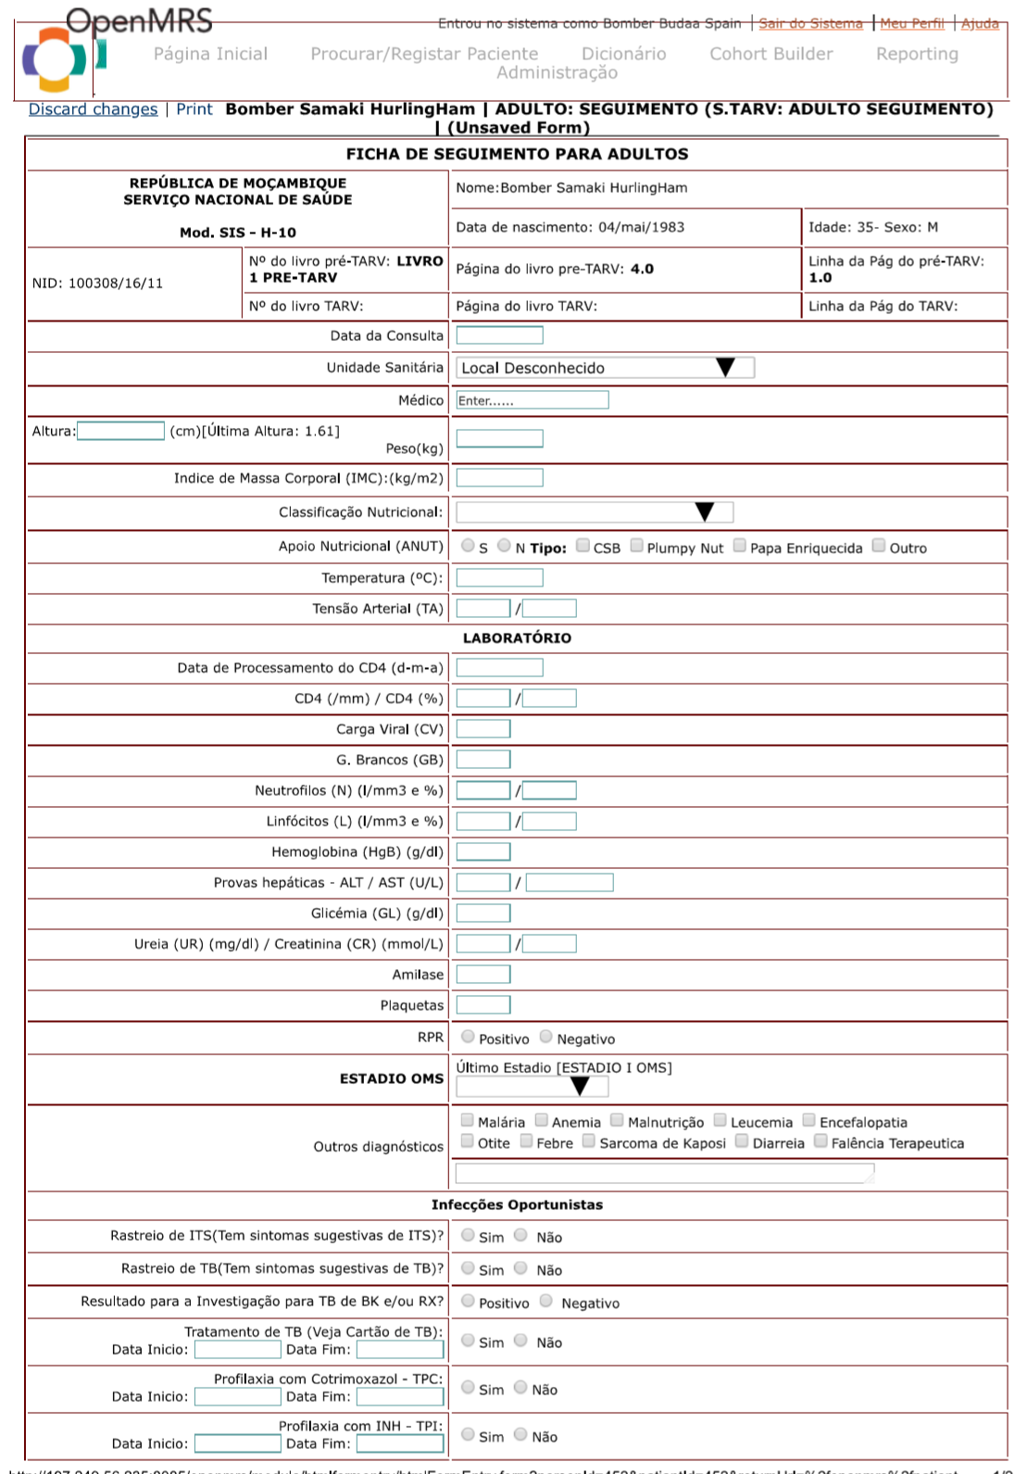
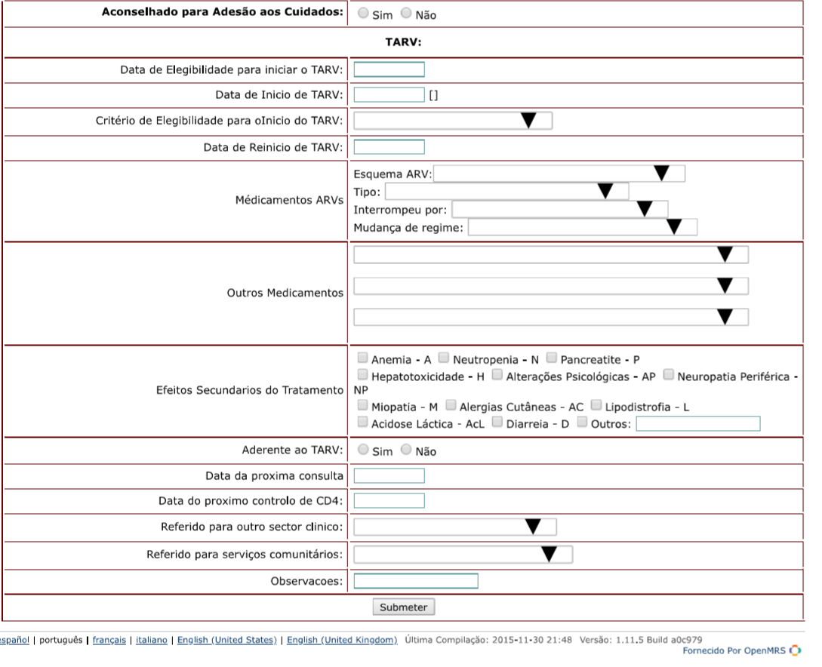

Annex 4- Pediatric Consultation Form
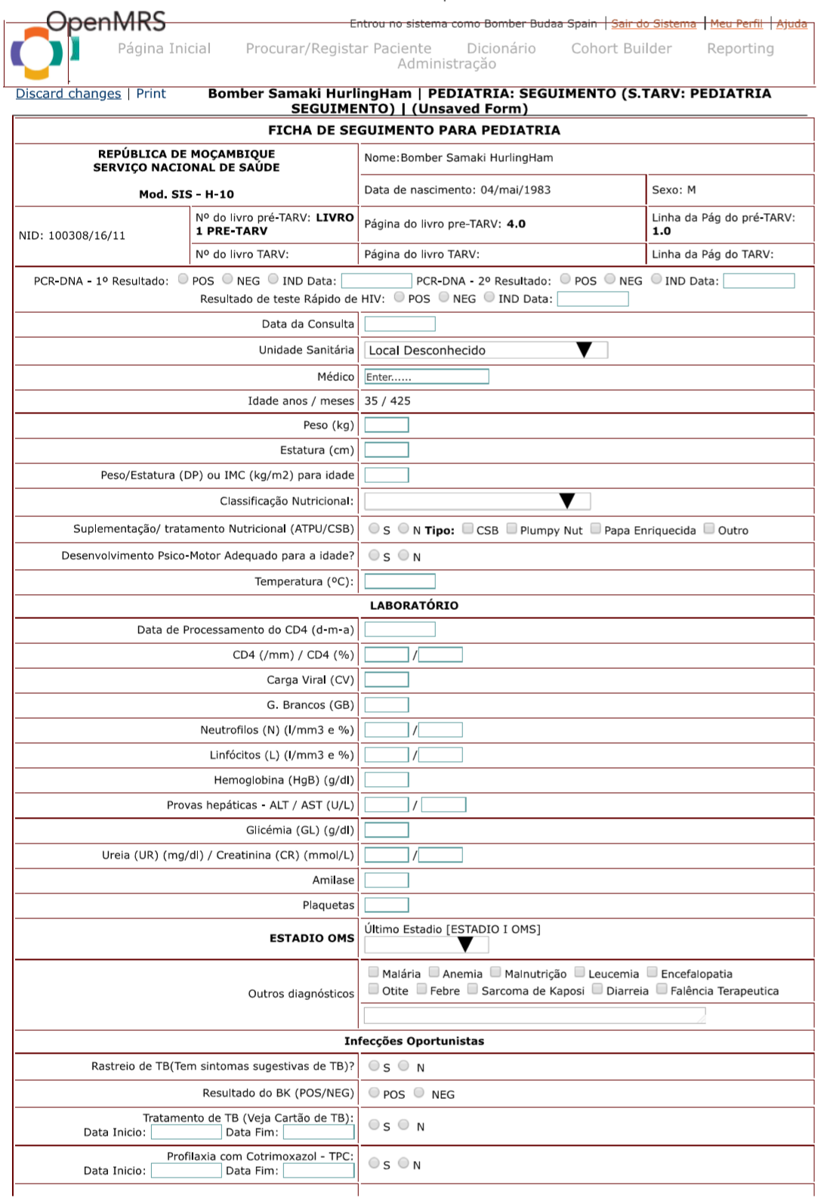
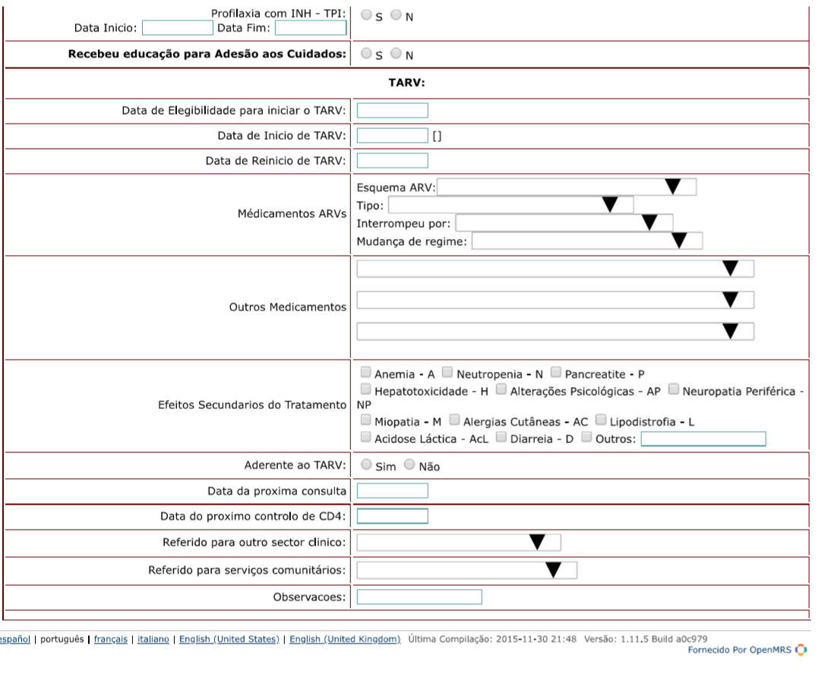
Annex 5- PEPFAR MER Reporting Schedule Table 2018
QTR | Reporting Start Date | Reporting End Date | Partners Submit Data By: Open MRS report is generated sometime before this date (see next column) | USG submits data to OGAC by | Cleaning period start/end date
Q1 | 21-Sep-18 | 20-Dec-18 |  | 01/08/18 – 02/15/18 | 03/05/18 – 03/23/18
Q2 | 21-Dec-18 | 20-Mar-19 |  | 04/02/18 – 05/15/18 | 06/04/18 – 06/22/18
Q3 | 21-Mar-19 | 20-Jun-19 |  | 07/02/18 – 08/15/18 | 09/04/18 – 09/21/18
Q4 | 21-Jun-19 | 20-Sep-19 |  | 10/01/18 – 11/15/18 | 12/03/18 – 12/21/18

